Rim Interface Document
September 15, 2006
DRD

1 - Introduction
This document describes the “rim” box, which resides on the lower edge of the primary and provides power and some control to the front-end. Figure 1 shows a picture of the box and interior. The components in the rim box comprise the following: (1) cryocooler power board, (2) rim power board, (3) rim control board, (4) TEC control board, (5) 24 V power supply.

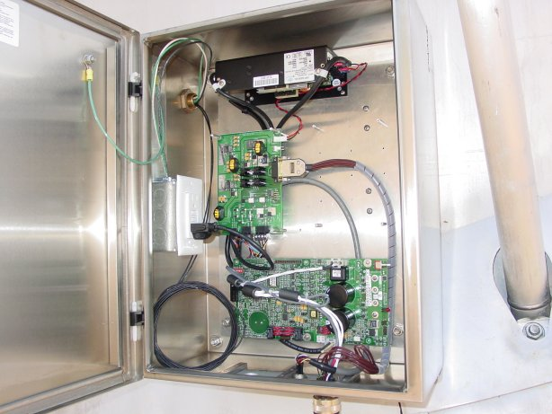
Figure 1: Rim-box enclosure. [Note, this picture does not show the rim controller or TEC controller].

II – Cryocooler Power Board
This interface document is based on the STI control board firmware design document (FirmwareDesign.pdf) from Paul Crowder in June 2006. This section will summarize the interface, for full details see the Crowder write-up (attached as an appendix).

The element state vector was distilled by looking through the numerous windows and parameters in the STI “portal” software.

The STI sterling cryocooler is controlled and powered by the STI control board, which they use for their entire cell phone product. We use it solely to power and control the cryocooler.

The control board communicates to a host computer via an asynchronous RS232 protocol with the following parameters:
Comm rate | 19200 bps
Data bits | 8
Parity | None
Stop bits | 1
Flow control | None
The communications protocol is query-response using XML tags. The details may be found in FirmwareDesign.pdf. The format for query and response is

<item attribute=”optional”>
ascii data
</item>

If there are no data, this may be shortened to
<item attribute=”value”/>

For example:

<TN OP=”GT” LC=”MS/>

might return

<TN OP=”GT” LC=MS>2FFF 5678</TN>

III – Rim Power Board
The rim power board provides power to three locations. Two of the outputs are derived from 24 VDC input from the rim power supply and go to the rim control board and the pax. The other output is derived from 120VAC input and drives the feed focus motor.
770849-2/770522-1

